# **Name: Abdurrahman Qureshi**

# **Roll No: 242466**

Practical No: 1

Aim: Study of PC Motherboard Technology (South Bridge and North Bridge), Internal Components and Connection Used in Computer System

Study of PC Motherboard Technology

A motherboard is the main circuit board of a computer, responsible for connecting and facilitating communication between various components. It includes several key sections, including the North Bridge and South Bridge, which help manage data flow between the processor, memory, storage, and peripherals.

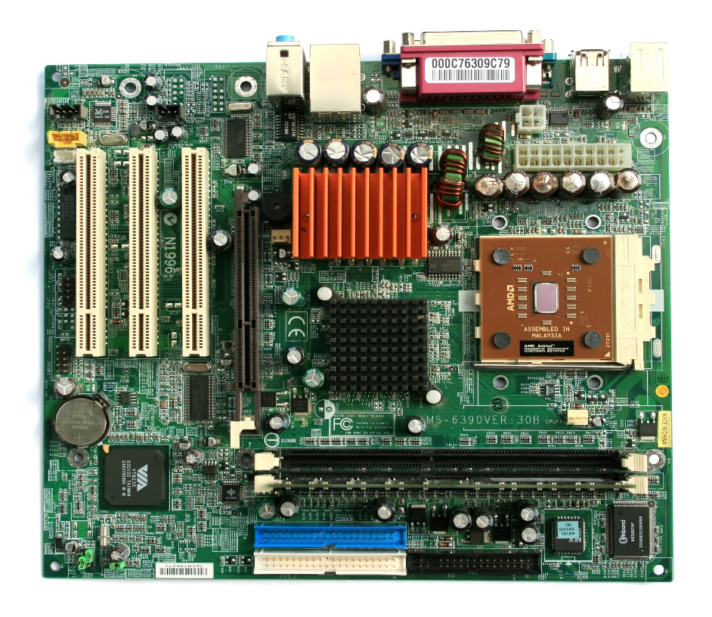

[This Photo](https://commons.wikimedia.org/wiki/File:MicroATX_Motherboard_with_AMD_Athlon_Processor_2_Digon3.jpg) by Unknown Author is licensed under [CC BY-SA](https://creativecommons.org/licenses/by-sa/3.0/)

The chipset of a motherboard is divided into two main parts:

1.1 North Bridge

* The North Bridge is responsible for handling high-speed communications.
* It connects directly to the CPU, RAM, and PCIe (or AGP) slots.
* It manages data flow between the processor and memory.
* It has a high-speed bus to handle data-intensive tasks.

Components Connected to North Bridge:

* CPU (Central Processing Unit): The brain of the computer that processes instructions.
* RAM (Random Access Memory): Temporary storage used by the CPU to store active tasks.

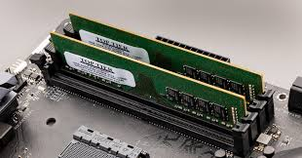

* Graphics Card (PCIe or AGP Slot): Dedicated hardware for processing visuals.

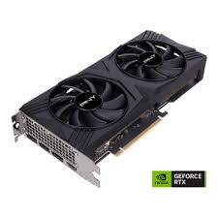

* High-Speed Buses: Such as the Front-Side Bus (FSB) for communication between CPU and memory.

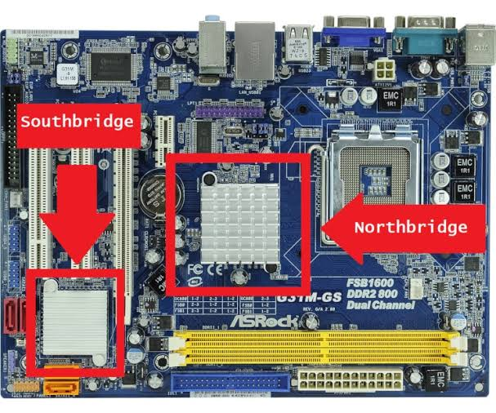

1.2 South Bridge

* The South Bridge manages lower-speed connections and I/O functions.
* It connects peripherals and storage devices.
* It handles USB ports, SATA, PCI slots, BIOS, and audio interfaces.
* Unlike the North Bridge, it does not directly interact with the CPU.

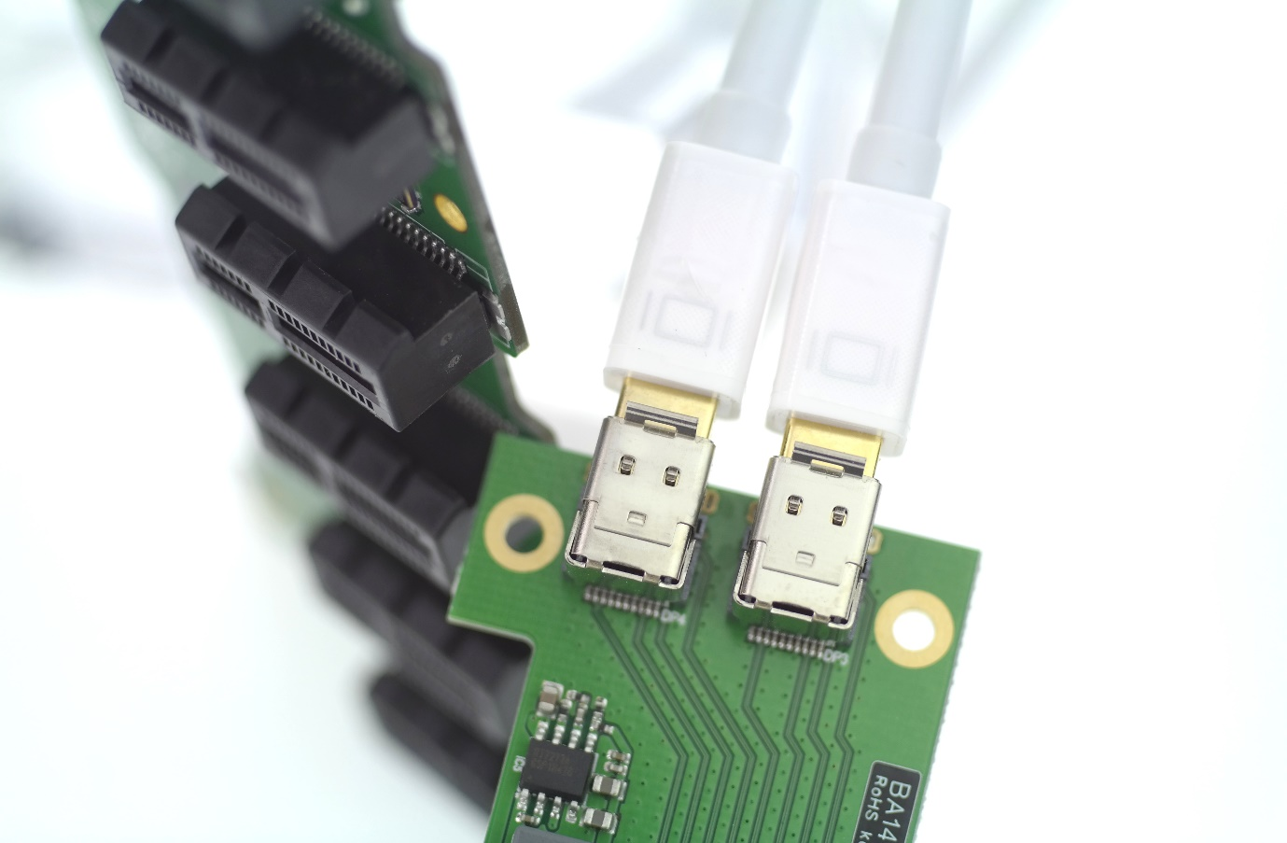

Components Connected to South Bridge:

* SATA Ports: For connecting hard drives and SSDs.
* USB Controllers: Managing USB devices such as keyboards, mice, and external drives.
* BIOS/UEFI Firmware: The system firmware that initializes hardware at start up.
* Audio and Network Controllers: For sound and Ethernet/wireless networking.

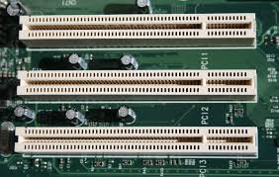

2. Internal Components of a Motherboard

2.1 CPU Socket

* A dedicated slot where the processor (CPU) is installed.
* Common types include LGA (Intel) and PGA (AMD).

2.2 RAM Slots (DIMM Slots)

* Holds memory modules (RAM) for fast, temporary data access.

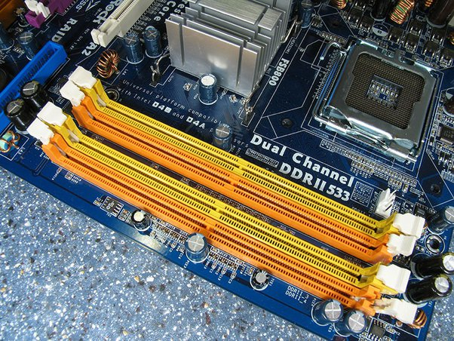

2.3 Expansion Slots

* PCIe (Peripheral Component Interconnect Express): Used for graphics cards, Wi-Fi adapters, SSDs.
* PCI (Older Standard): For legacy expansion cards.

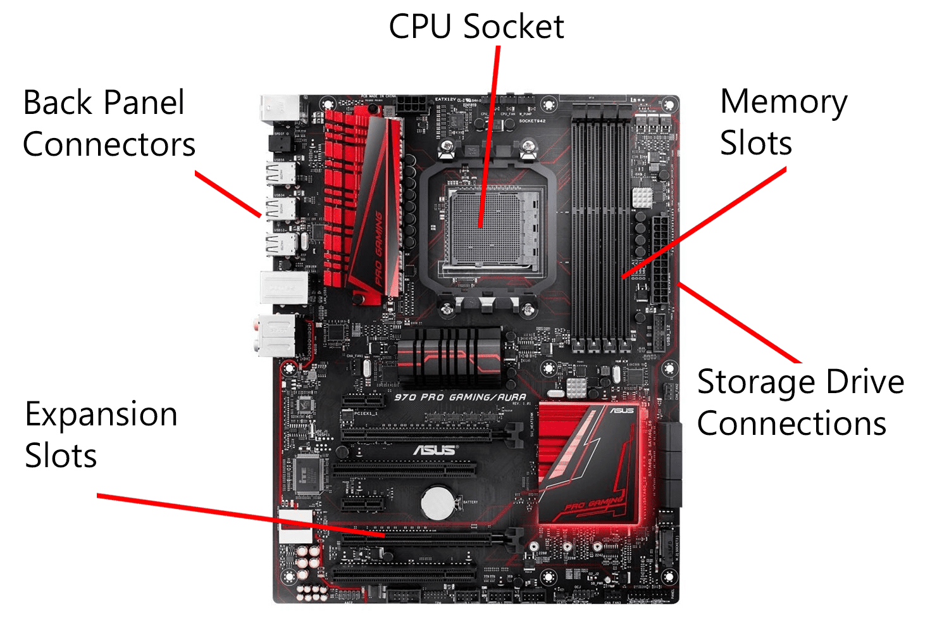

2.4 Power Connectors

* 24-Pin ATX Power Connector: Main power supply to the motherboard.
* 8/4-Pin CPU Power Connector: Supplies power specifically to the CPU.

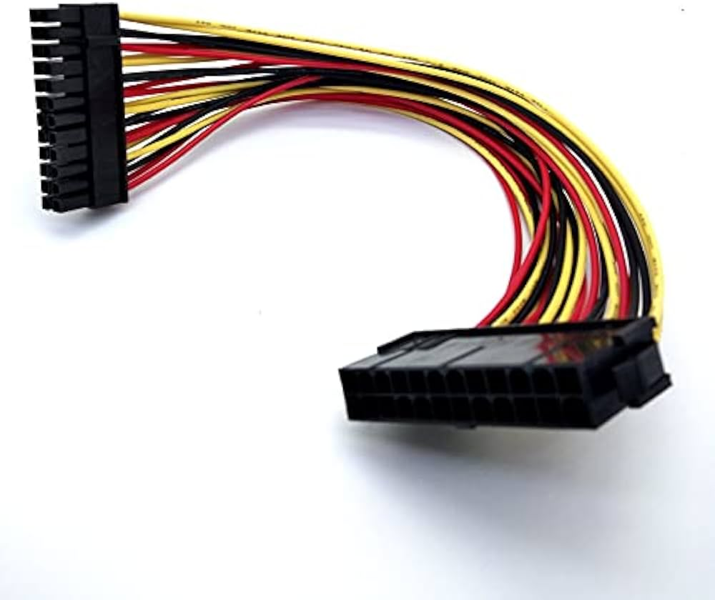

2.5 Storage Interfaces

* SATA Ports: Used to connect HDDs, SSDs, and optical drives.
* M.2 Slot: Supports high-speed NV Me SSDs.

2.6 Input/Output (I/O) Ports

* USB Ports: For peripherals like flash drives and external hard disks.
* Ethernet Port: For wired networking.
* Audio Jacks: For speakers and microphones.
* HDMI/DisplayPort/VGA: For video output to monitors.

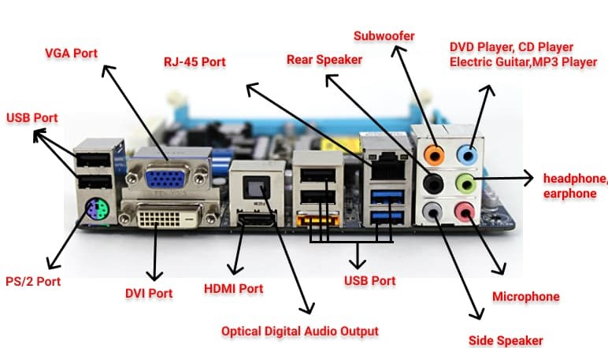

3. Connection Technologies Used in a Computer System

3.1 Internal Connections

* Bus System: Transfers data between components (FSB, PCIe, SATA).
* Chipset: Controls data flow between CPU, memory, and storage.

3.2 External Connections

* USB (Universal Serial Bus): For connecting external storage, peripherals.
* Thunderbolt: High-speed data transfer and display connectivity.
* Ethernet & Wi-Fi: Network connections for internet and LAN.

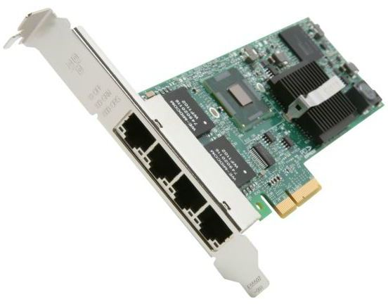

3.3 Cooling System

* Heat Sinks & Fans: Dissipate heat from the CPU and chipset.
* Liquid Cooling: Advanced cooling for high-performance systems.

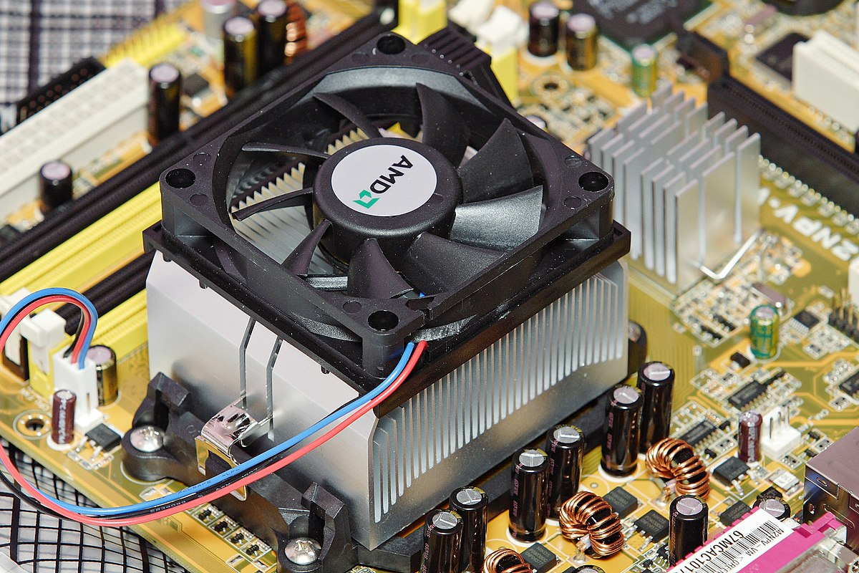

Conclusion:

Hence, we studied the PC Motherboard Technology (South Bridge and North

Bridge). Internal Components and Connections used in computer system

|  |  |  |  |  |  |
| --- | --- | --- | --- | --- | --- |
| Performance  (7M) | Journal  (3M) | Lab Ethics  (2M) | Attendance  (3M) | Total  (15M) | Faculty Signature |
|  |  |  |  |  |  |